**DATA MANAGEMENT**

**AIM:**

To import data with the Data Import Wizard in Salesforce Lightning Experience.

**PROCEDURE:**

**STEP 1 :** Prepare your data in the form of excel sheet for import and create an import

file.

**STEP 2 :** Start the wizard From Setup, enter “Data Import Wizard” in the Quick Find

box, then select Data Import Wizard. Review the information provided on

the welcome page, then click Launch Wizard.

**STEP 3 :** Choose the data that you want to import. To import accounts, contacts,

leads,solutions, person accounts, or articles, click Standard Objects.

Click Standard object to import Account related records.

You will find a wizard at the right side that has the following 3 options:

Add new records

Update existing records, or

Add and update records

Choose “Add new records” and then choose your corresponding CSV file to import and specify matching and other criteria as necessary. Hover your mouse over the question marks for more information about each option.

Then, choose a character encoding method for your file. Typically, you don’t change your character encoding.

Select comma or tab as a value separator.

Click Next.

**STEP 4 :** Map your data fields to Salesforce data fields.

* The Data Import wizard maps as many of your data fields as possible to standard Salesforce data fields.
* But if the wizard can’t map fields, you must do it manually.
* (Note: Unmapped fields are not imported into Salesforce.)

**STEP 5 :** Review and start your import.

Review your import information on the Review page. If you still have

unmapped fields that you want to import, click Previous to return to the

previous page and specify your mappings.

Click Start Import.

**STEP 6 :** Check import status. Go to SetUpà App Launcher à Select Account standard object à In Details tab, you can see the records that are imported now.

**OUTPUT:**

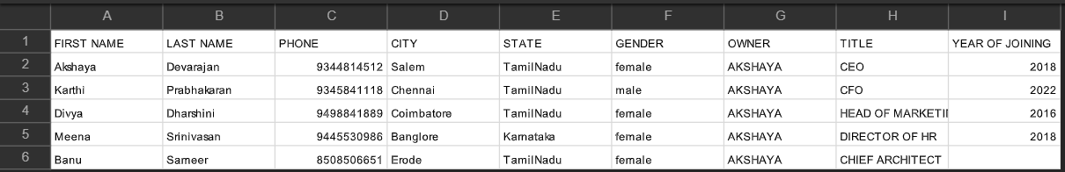

CREATE AN EXCEL FILE AND SAVE IT

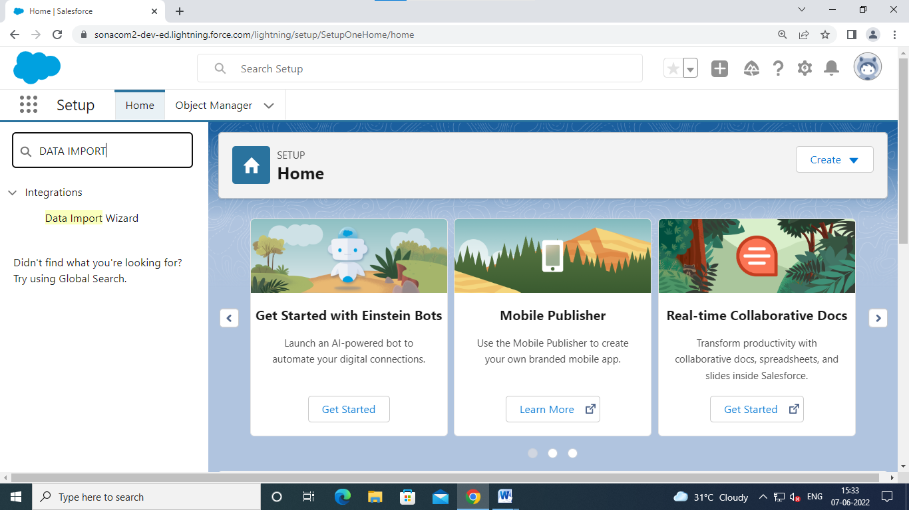

GOTO QUICK FINDER AND SELECT DATA IMPORT

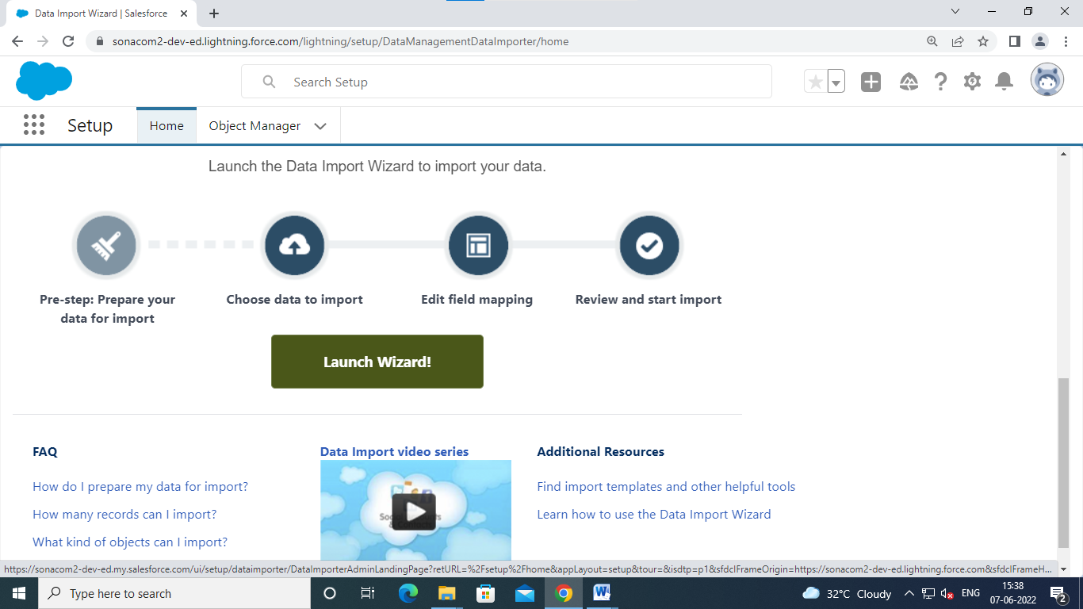

CLICK LAUNCH WIZARD

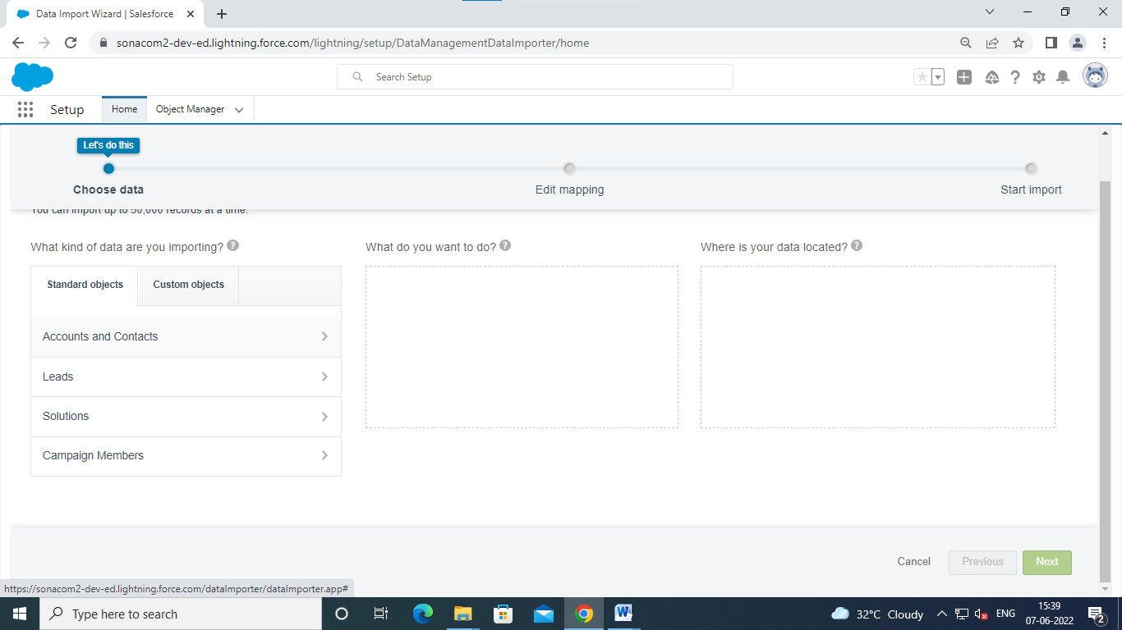

Choose account and contact

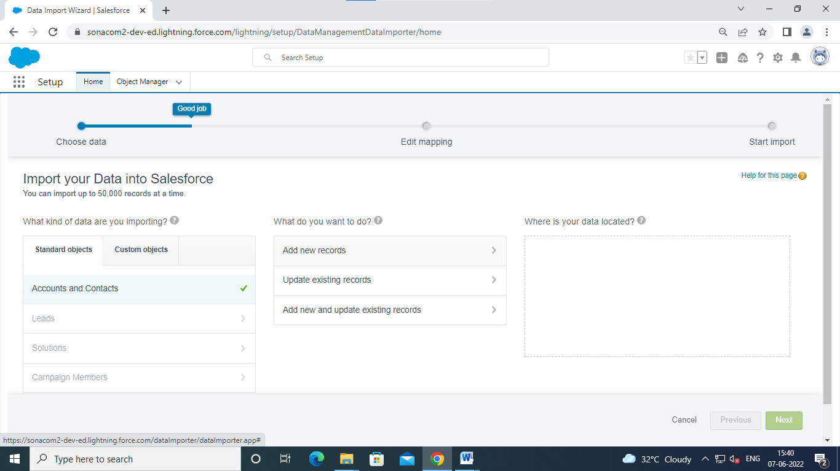

Choose add new record

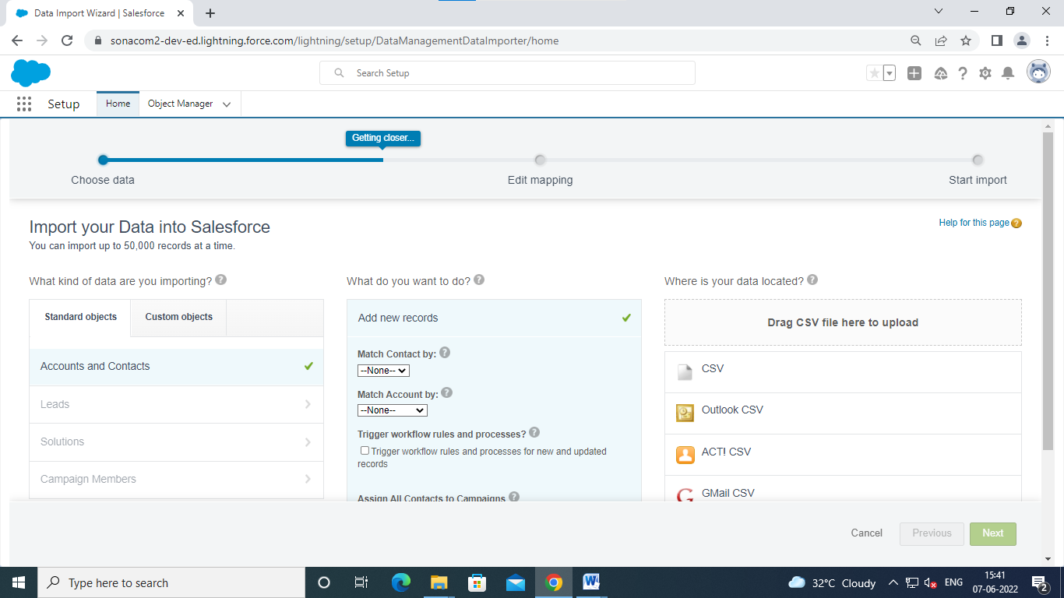

Choose csv

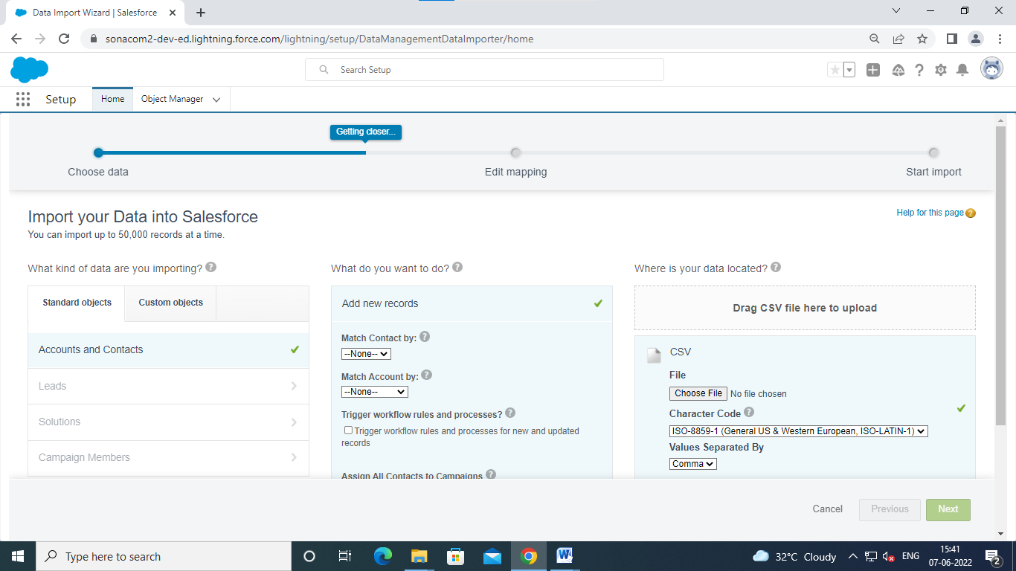

Click Choose file

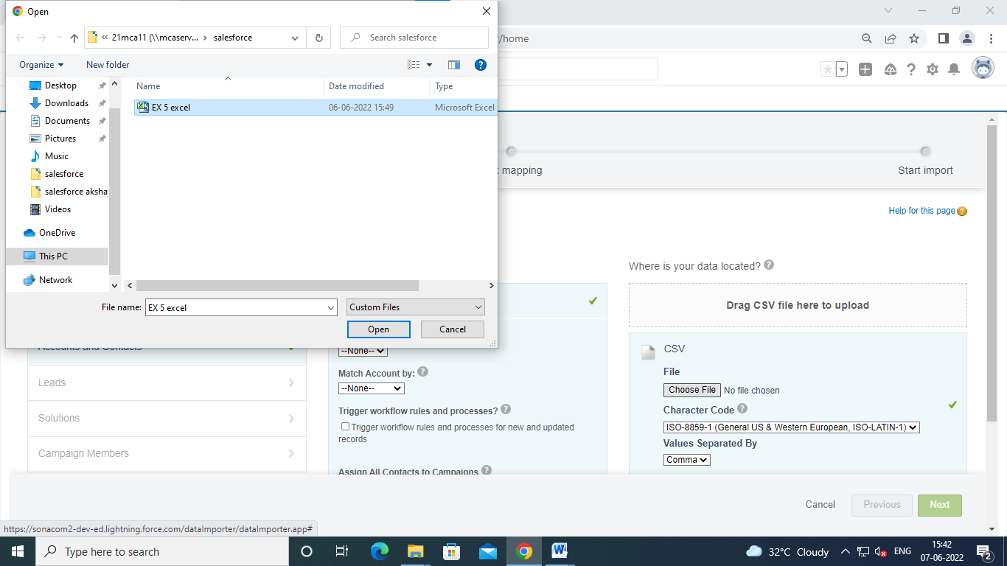

Select the file

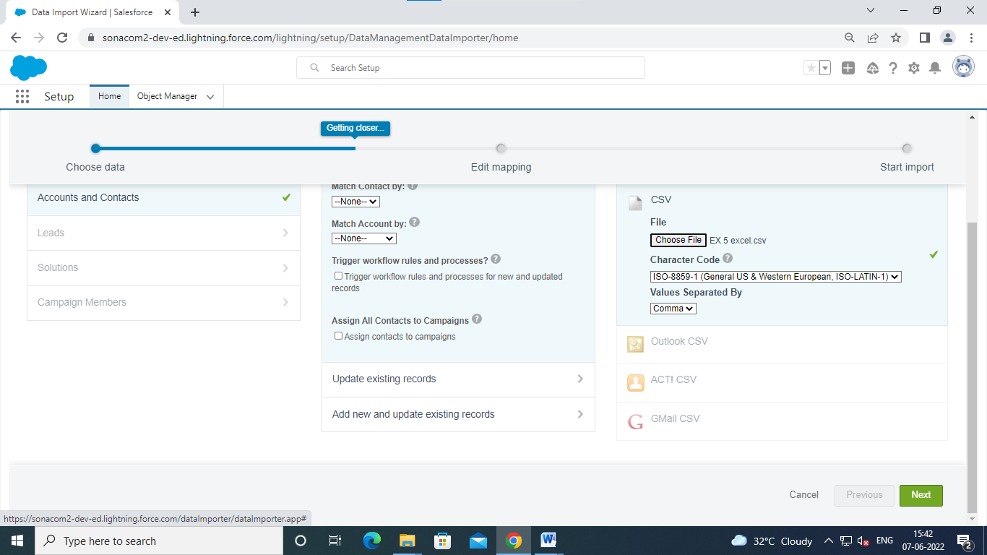

Click next

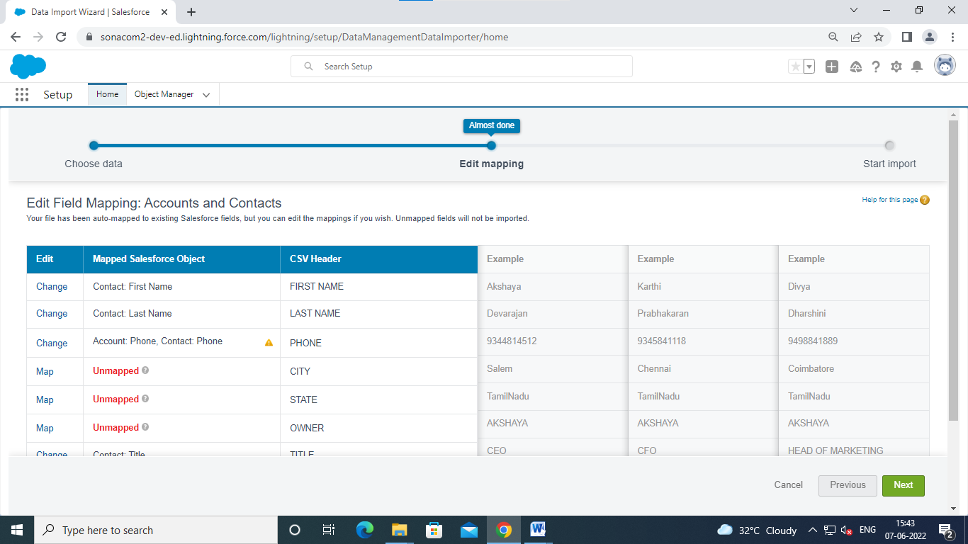

Click unmapped row and click on map

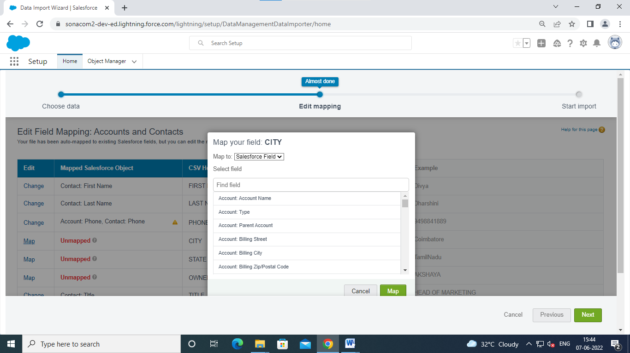

Choose account billing city

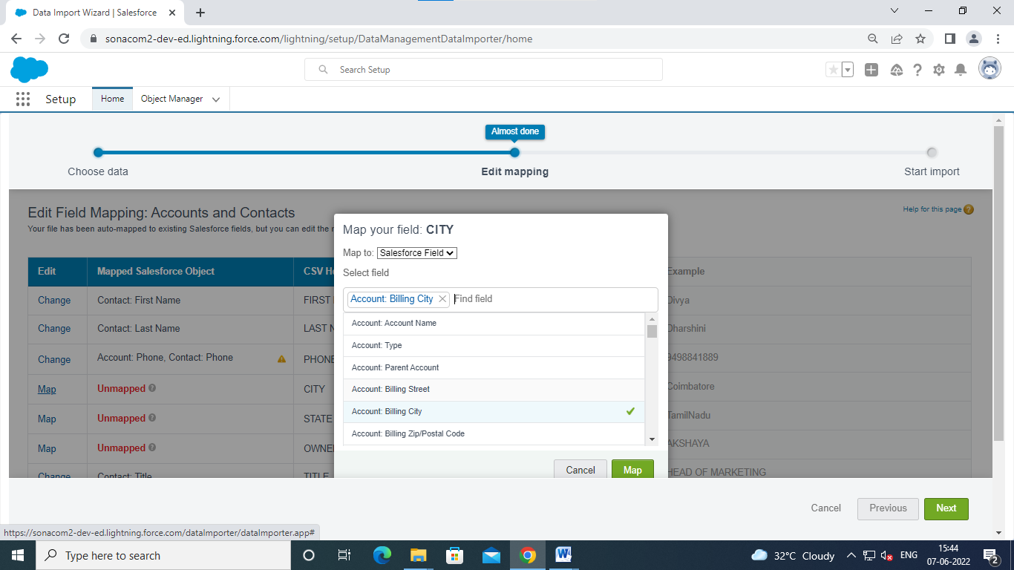

Click map

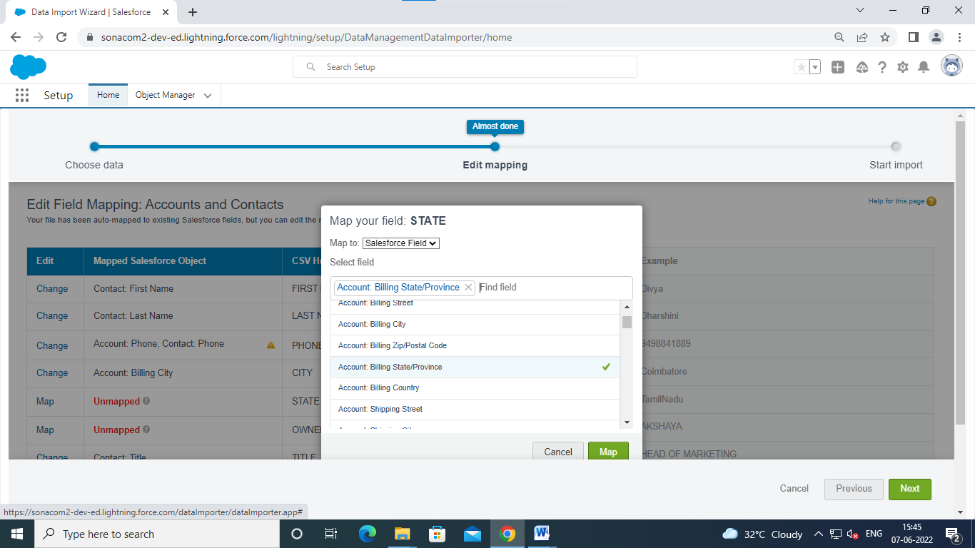

(for second umapped) click map

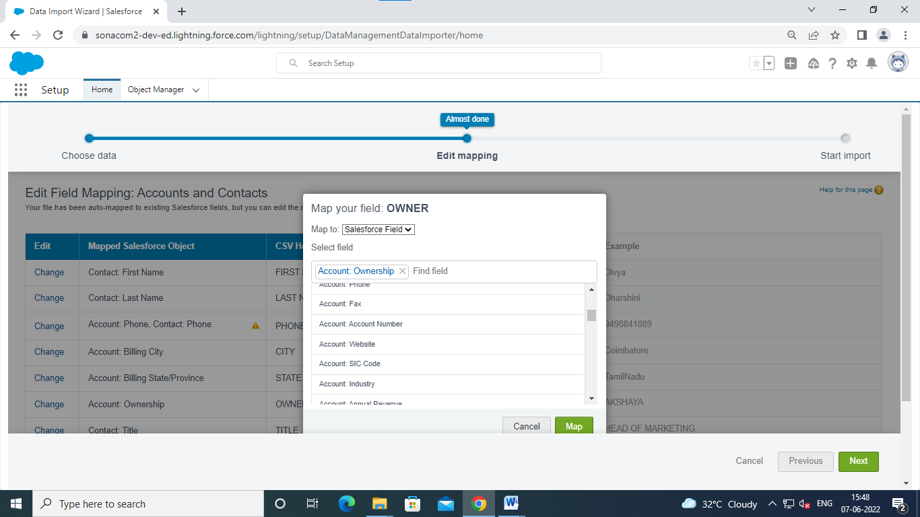

Click map

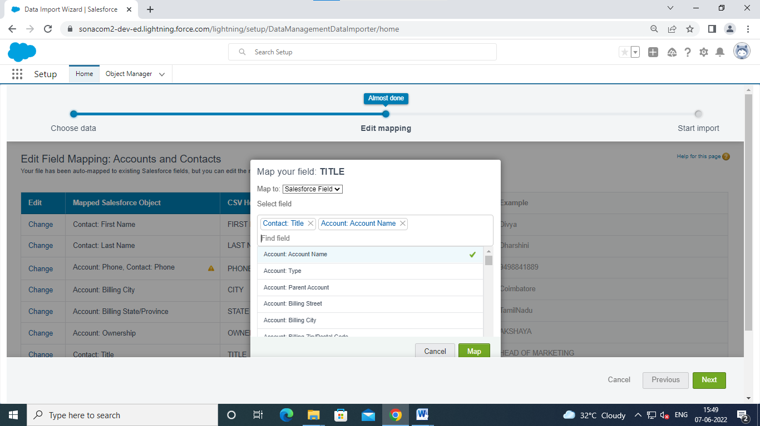

In Contact title row click change and add field and click map

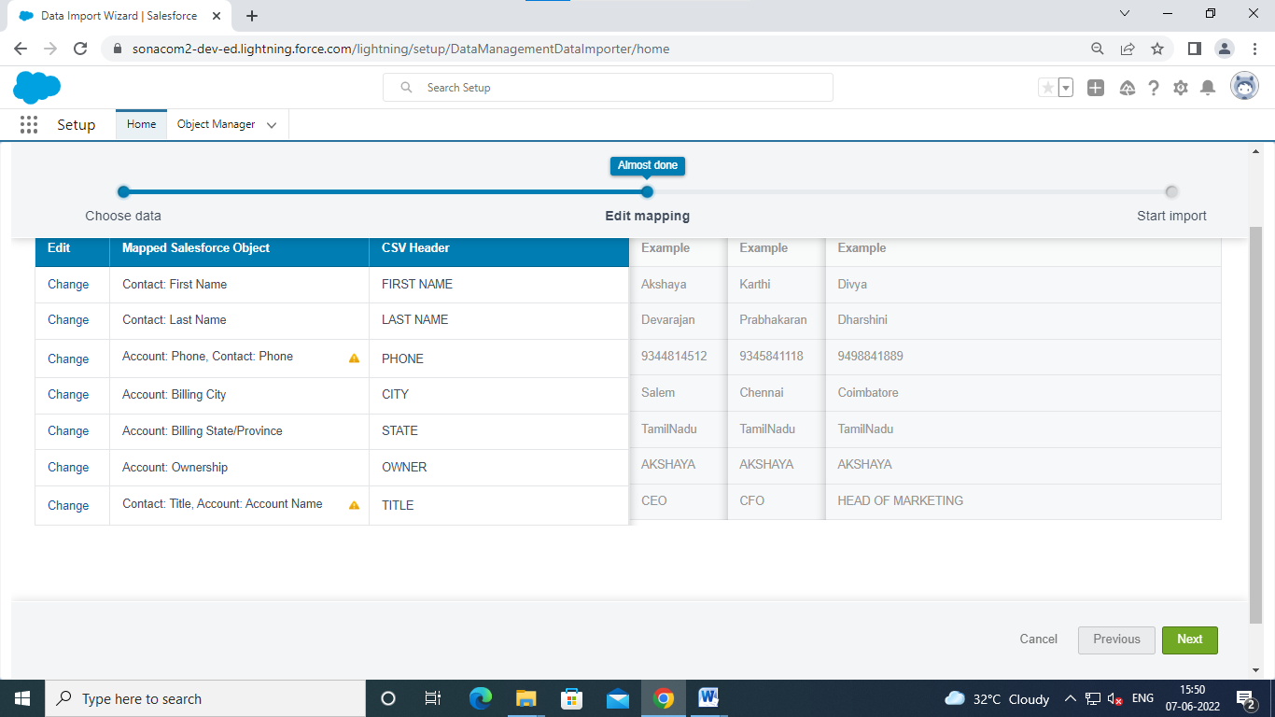

Click next

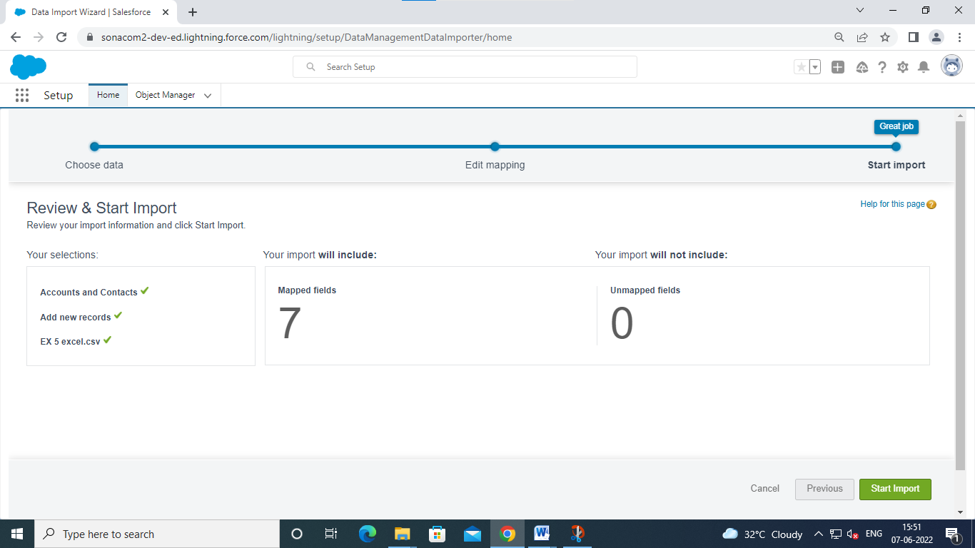click start import

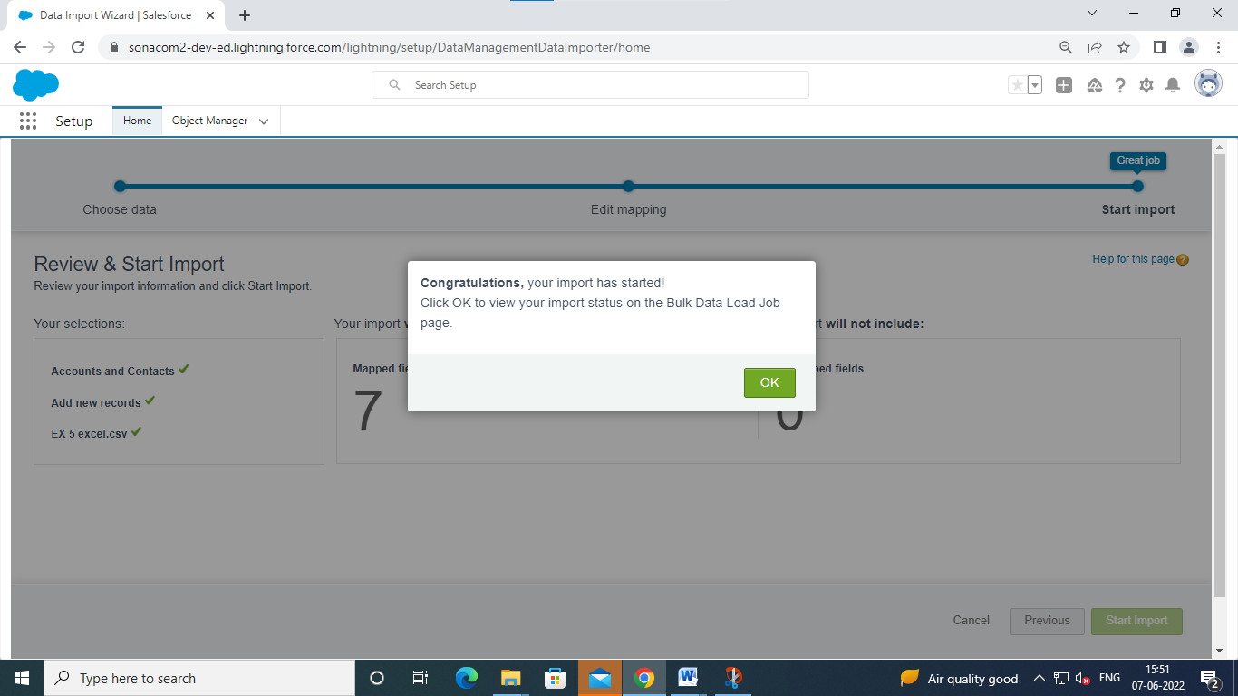click ok

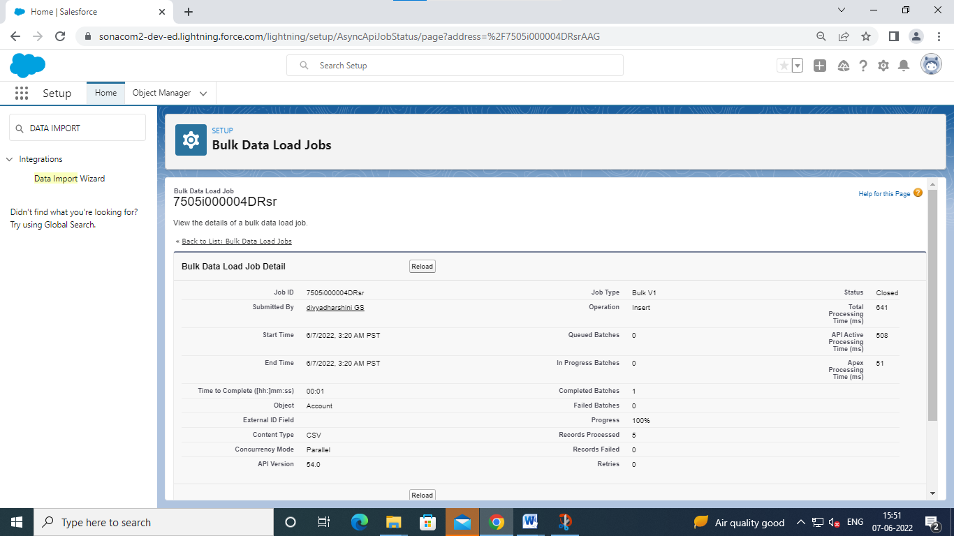

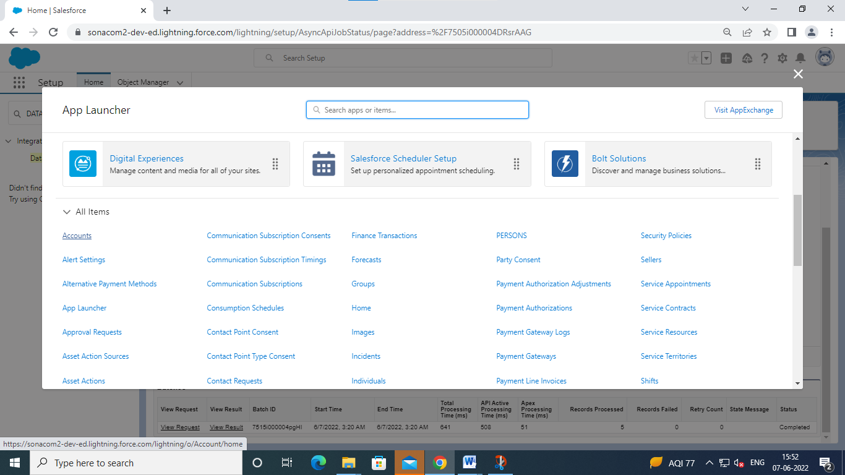choose accounts

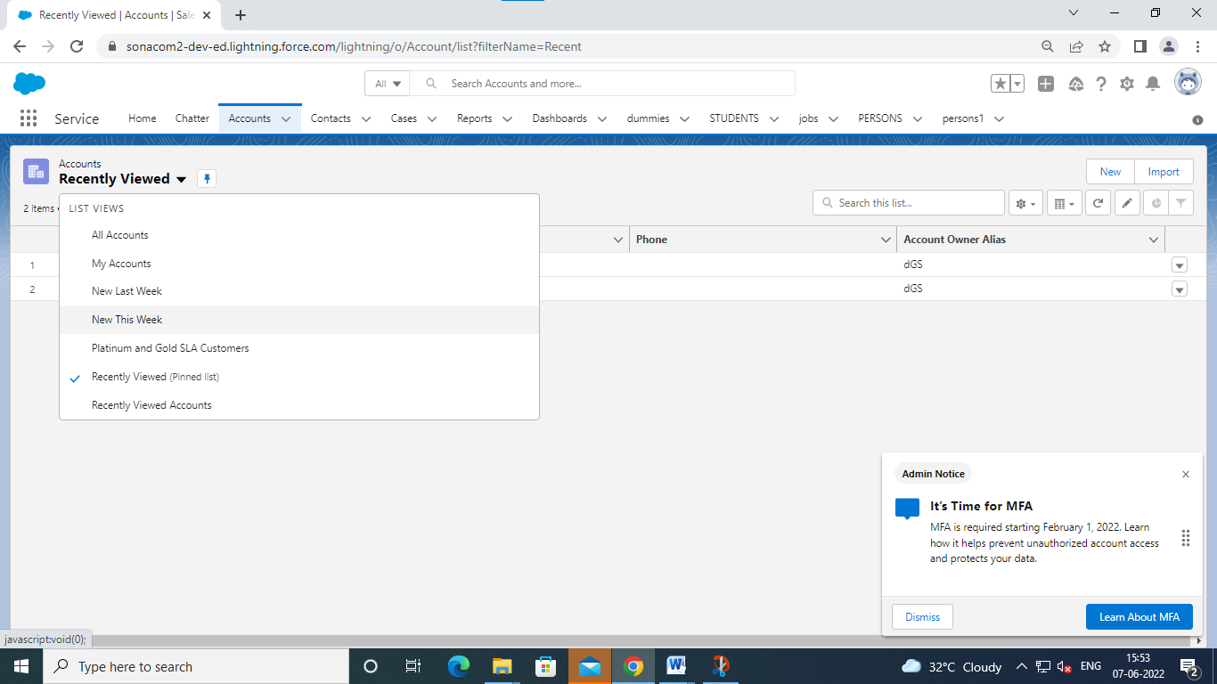in recently viewed click new this week

